Slide 1: Introduction: Organization Design Reflection

Slide 2: Empowering Women through Organization and Design

Slide 3: Overview of the Current Work Environment

Current challenges for women in leadership:

* Underrepresentation in leadership roles
* Lack of mentorship and career development
* Wage gaps and unequal promotion opportunities
* Importance of promoting diversity and inclusion

Issues Related to Women in Leadership

* Lack of Representation: Women are underrepresented at senior levels
* Limited Access to Mentorship: Fewer networking and sponsorship opportunities
* Work-Life Balance: Lack of flexible work arrangements
* Gender Bias: Unconscious bias affecting decision-making and promotions

Slide 4: Proposed Organizational Design

Matrix Structure:

* Blends divisional and functional lines of authority
* Encourages cross-functional collaboration and flexibility
* Supports knowledge exchange and diverse decision-making

Goal: Empower women through strategic positioning and career growth

Slide 5: Graphical Representation of the Design

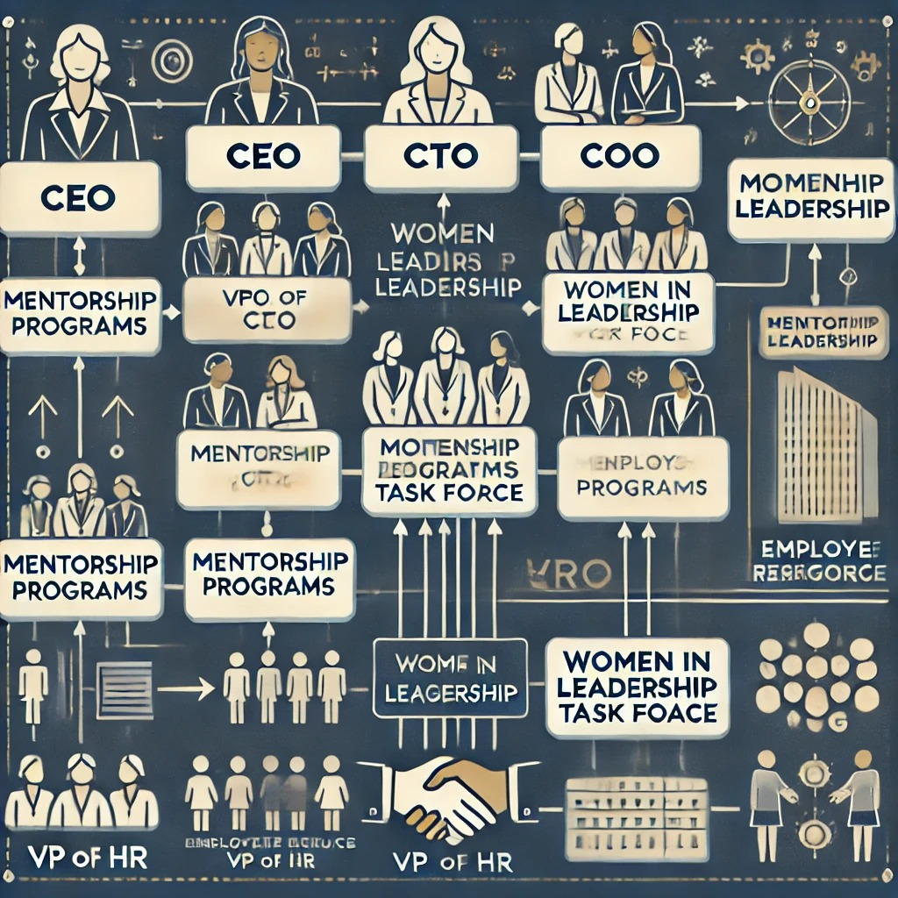

Board of Directors → CEO

Functional Heads: CTO, CFO, COO, VP of IT, VP of HR

Diversity and Inclusion Council advising the Board

ERGs and Mentorship Programs supporting career growth

Slide 6: Cultural Elements

Diversity and Inclusion:

* Ensure leadership reflects employee diversity
* Encourage different perspectives in decision-making
* Fairness and Transparency:
* Clear promotion and salary adjustment guidelines
* Regular pay audits and progress tracking

Career Development:

* Leadership training tailored to women’s challenges
* Executive coaching and strategic planning workshops
* Sponsorship and mentorship programs

Slide 7: Impact on the Organization

Enhanced Representation: Greater presence of women in leadership

Higher Employee Satisfaction: Increased job loyalty and retention

Improved Decision-Making: Diverse perspectives lead to better business outcomes

Financial Growth: Stronger business performance and market competitiveness

Slide 8: Reflection on Course Experience

Key lessons from the course:

* Importance of inclusive leadership
* Effective organizational design and strategy
* How mentorship and sponsorship empower women

Application to professional life:

* Advocating for transparent policies and diversity initiatives
* Promoting flexible work arrangements
* Application of Lessons Learned

Professional development strategies:

* Implementing ERGs and mentorship programs
* Ensuring fair evaluation processes
* Encouraging open communication and accountability

Personal growth:

* Confidence in leading change
* Supporting other women in their career progression

Slide 9: Conclusion and Next Steps

Summary of Key Points:

* Matrix structure supports diversity and leadership growth
* Cultural values of fairness, inclusion, and accountability

Career development and strategic mentorship

Next Steps:

Implement the design and measure progress

Create feedback loops for continuous improvement

Develop targeted leadership programs for women

Slide 10- Thank you. It’s been a pleasure.

Kamber M Teets

OSL-676 Women in Leadership

10-1 Presentation: Organizational Design Reflection

03/16/2025

Audio Narration

**Slide 1:**

"Welcome and thank you for joining me. Today, I’ll be discussing how thoughtful organizational design can empower women in leadership. We'll explore how strategic structures, inclusive cultures, and targeted career development can drive meaningful change and create new opportunities for women to thrive."

**Slide 2:**

"The goal of this plan is to create a structure and culture that supports women in leadership roles. This will be achieved by implementing a matrix design that promotes flexibility and collaboration, fostering a diverse and inclusive work environment, and establishing clear career advancement paths."

**Slide 3:**

"Currently, women face several challenges in leadership roles. They are underrepresented in senior positions, have limited access to mentorship, experience wage gaps, and face unequal promotion opportunities. Additionally, unconscious bias and the lack of flexible work arrangements further limit women's progress."

**Slide 4:**

"The proposed matrix structure blends divisional and functional lines of authority. This encourages cross-functional collaboration and knowledge sharing, enhancing flexibility and strategic decision-making. The goal is to empower women by positioning them strategically for career growth and increased influence."

**Slide 5:**

"Here’s a visual representation of the proposed structure. At the top, the Board of Directors oversees the CEO, who manages functional heads, including the CTO, CFO, COO, VP of IT, and VP of HR. The Diversity and Inclusion Council advises the Board, while Employee Resource Groups and mentorship programs provide career growth support."

**Slide 6:**

"The cultural elements include ensuring leadership reflects the diversity of employees and encouraging different perspectives in decision-making. Fairness and transparency are promoted through clear promotion guidelines and regular pay audits. Career development is supported by tailored leadership training, executive coaching, and strategic mentorship programs."

**Slide 7:**

"The anticipated impact includes enhanced representation of women in leadership, higher employee satisfaction, improved decision-making through diverse perspectives, and stronger business performance and market competitiveness."

**Slide 8:**

"Reflecting on the course experience, I’ve learned the importance of inclusive leadership and effective organizational design. In my professional life, I plan to advocate for transparent policies and flexible work arrangements, implement ERGs and mentorship programs, and ensure fair evaluation processes. Personally, I feel more confident in leading change and supporting other women."

**Slide 9:**

"In summary, the matrix structure will support diversity and leadership growth. Cultural values of fairness, inclusion, and accountability will strengthen the organization, while targeted career development programs will empower women to thrive. Next steps include implementing the design, tracking progress, and refining strategies based on feedback."

**Slide 10:**

"Thank you for your time and attention. It’s been a pleasure presenting my Organizational Design Reflection. I’m excited about the future of empowering women in leadership roles."